Bahria University,

Karachi Campus



LAB EXPERIMENT NO. _10_

LIST OF TASKS

|  |  |
| --- | --- |
| TASK NO | OBJECTIVE |
| Task 1 | Write all programs to create a linked list. |
| Task 2 | Write a program to implement dynamic Stacks using linked list. |
| Task 3 | Write a program to implement dynamic queue by using linked list. |
| Task 4 | N/A |
| Task 5 | N/A |
| Task 6 | N/A |
| Task 7 | N/A |
| Task 8 | N/A |

Submitted On:

__04/06/2020__

(Date: DD/MM

**Task No. 1:** Write all programs to create a linked list.

**Coding:**

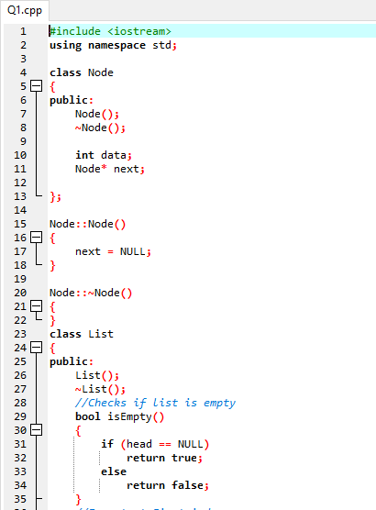 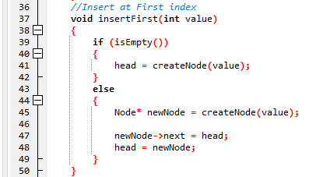

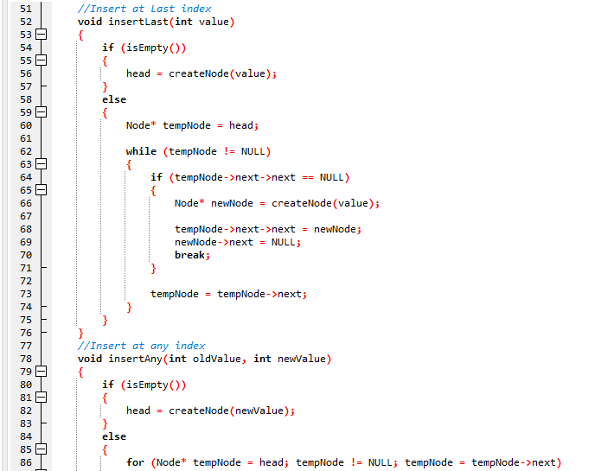

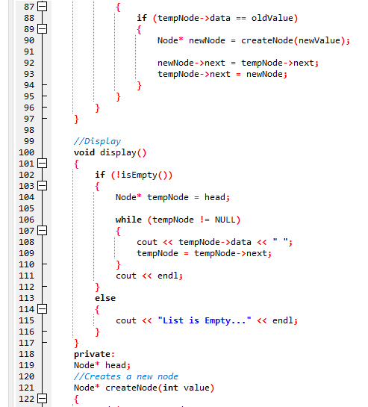

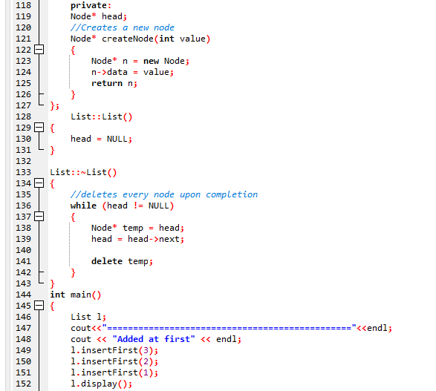 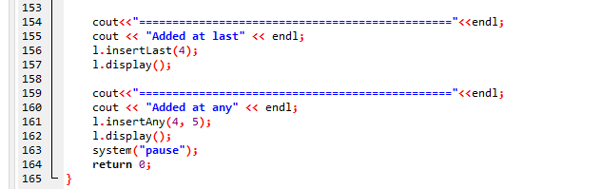**Output:**

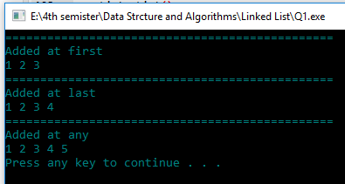

**Task No. 2:** Write a program to implement dynamic Stacks using linked list.

**Coding:**

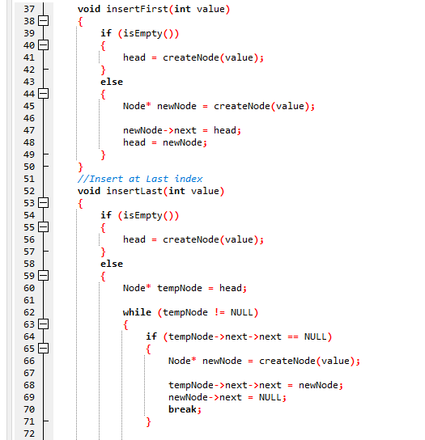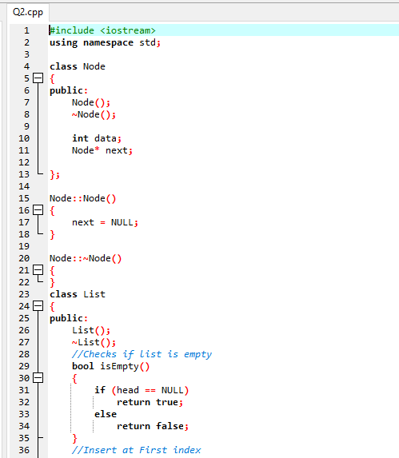

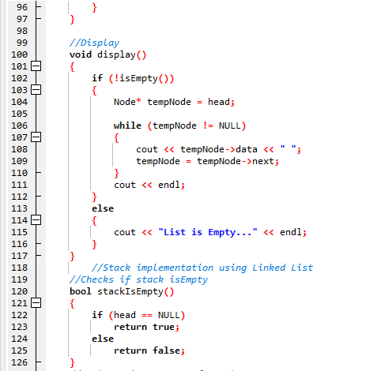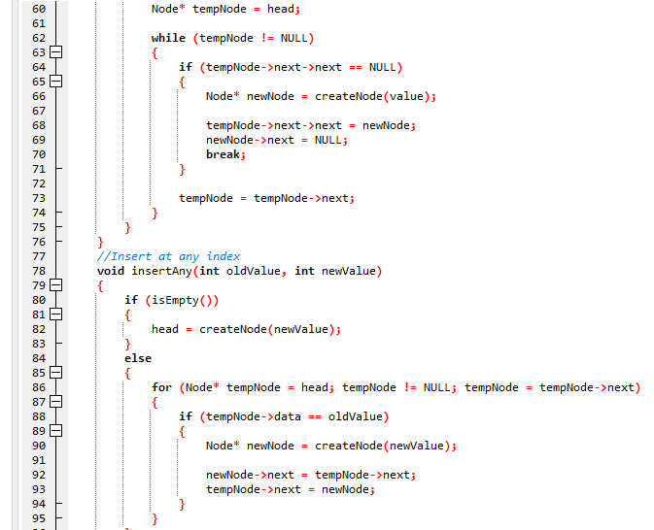

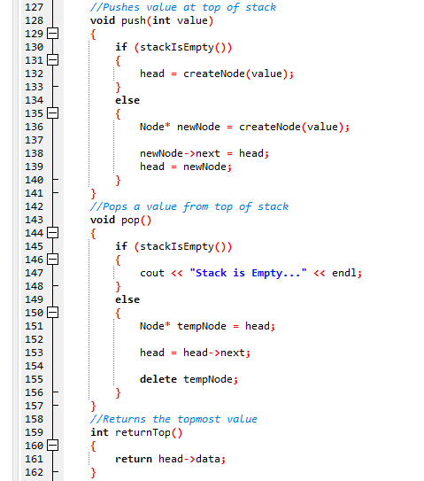 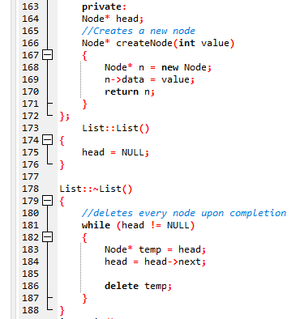

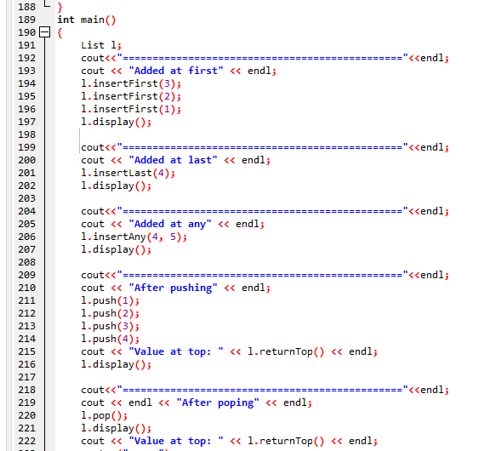

**Output:**

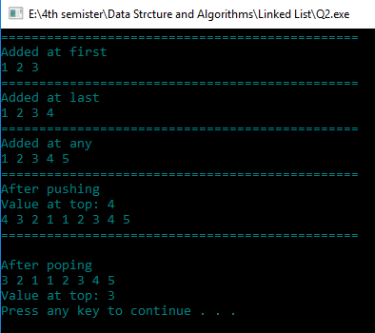

**Task No. 3:** Write a program to implement dynamic queue by using linked list.

**Coding:**

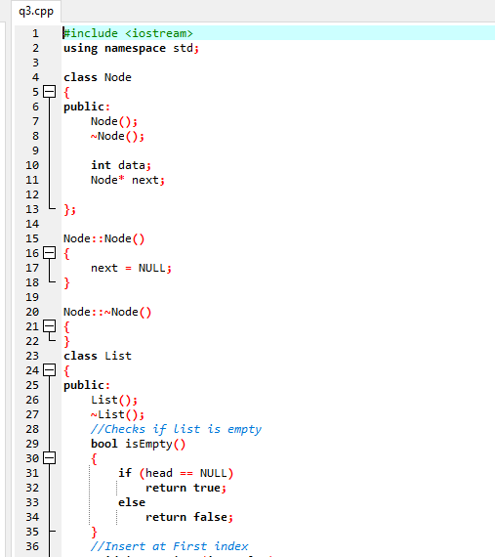 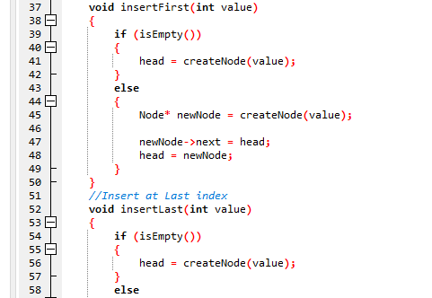

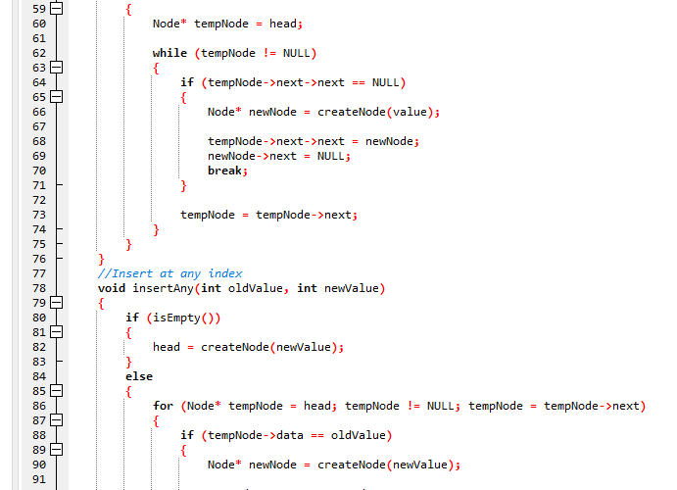 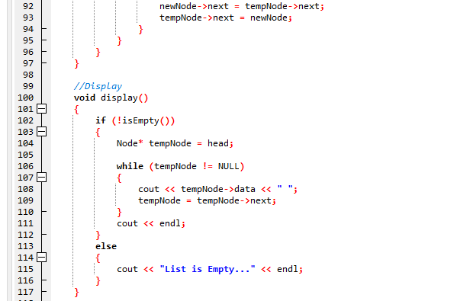 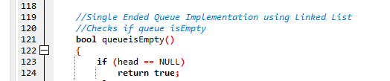

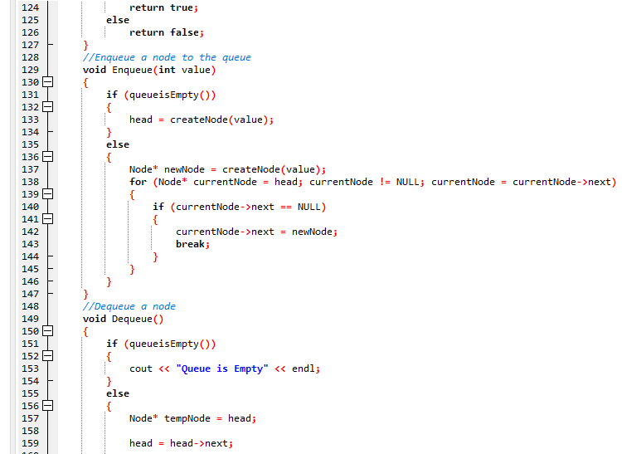 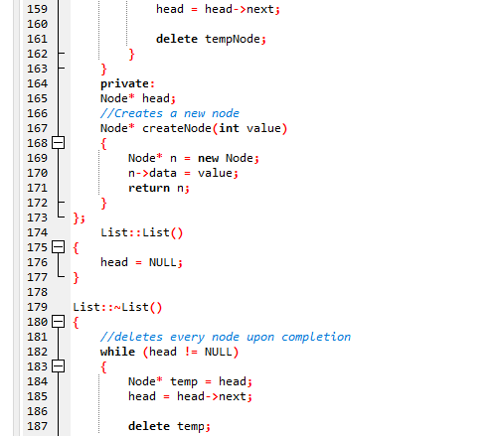

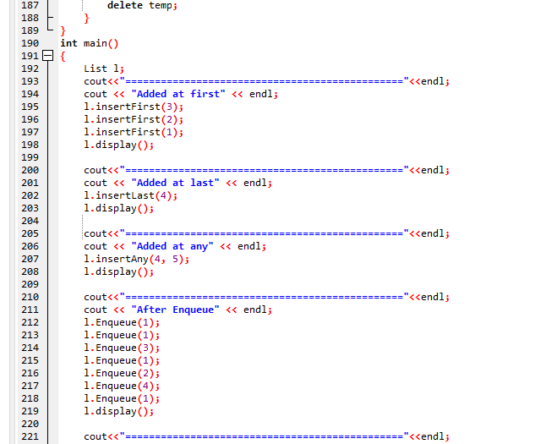 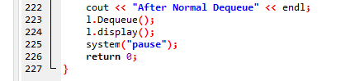

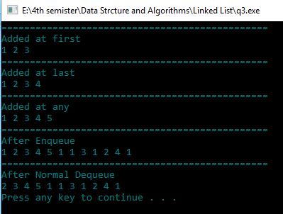**Output:**